**AIRLINE RESERVATION SYSTEM**

**A PROJECT REPORT**

**for**

**Mini Project-I (K24MCA18P)**

**Session (2024-25)**

**Submitted by**

**GULSHAN KUMARI**

**(202410116100078)**

**MUKUL DHIMAN**

**(202410116100126)**

**HIMANSHI SHARMA**

**(202410116100091)**

**Submitted in partial fulfilment of the**

**Requirements for the Degree of**

**MASTER OF COMPUTER APPLICATION**

**Under the Supervision of**

**Mr. Arpit Dogra**

### Assistant Professor



**Submitted to**

**Department Of Computer Applications**

**KIET Group of Institutions, Ghaziabad**

**Uttar Pradesh-201206**

**CERTIFICATE**

Certified that **Mukul Dhiman 202410116100126, Gulshan Kumari 202410116100078, Himanshi Sharma 202410116100091** has/ have carried out the project work having “**Airline Reservation System**” (**Mini Project-I, K24MCA18P**) for **Master of Computer Application** from Dr. A.P.J. Abdul Kalam Technical University (AKTU**)** (formerly UPTU), Lucknow under my supervision. The project report embodies original work, and studies are carried out by the student himself/herself and the contents of the project report do not form the basis for the award of any other degree to the candidate or to anybody else from this or any other University/Institution.

Mr. Arpit Dogra Dr. Arun Kumar .Tripathi

Assistant Professor Dean

Department of Computer Applications Department of Computer Applications KIET Group of Institutions, Ghaziabad KIET Group of Institutions, Ghaziabad

**AIRLINE RESERVATION SYSTEM**

**GULSHAN KUMARI**

**MUKUL DHIMAN**

**HIMANSHI SHARMA**

**ABSTRACT**

An Airline Reservation System is a comprehensive software platform designed to automate and streamline the process of flight booking, ticketing, and passenger management for both airline staff and customers. The system provides an integrated environment where users can search for flights, make reservations, select seats, process payments, and receive confirmation in real time. The system offers a user-friendly interface that allows customers to search for flights based on various parameters, such as destination, travel dates, and class of service. Once a flight is selected, passengers can view seat availability, choose seats, and complete the booking by making secure online payments through integrated payment gateways.

For airline staff, the system provides powerful administrative tools to manage flight schedules, allocate seats, update flight statuses, and handle customer queries. Real-time seat inventory management ensures that seat availability is always up-to-date, and the system minimizes overbooking by tracking reservations dynamically. Additionally, the ARS integrates with external systems, such as global distribution systems (GDS), payment processors, and customer relationship management (CRM) tools, to offer a seamless and efficient workflow.

The ARS also supports essential functions like automated ticket generation, online check-in, and real-time notifications regarding flight status changes, cancellations, or delays. Reporting and analytics tools help airlines track bookings, revenue, and operational performance, enabling better decision-making and revenue optimization. By automating repetitive tasks, reducing human error, and improving data accuracy, the system enhances operational efficiency, reduces costs, and provides a more convenient and satisfactory experience for travelers.

In conclusion, the Airline Reservation System serves as a vital tool for airlines to manage their flight operations while offering an enhanced, user-friendly booking experience for customers. It enables airlines to operate more efficiently, boost customer satisfaction, and generate higher revenue through improved resource management and seamless integration with other systems.

**TABLE OF CONTENTS**

Page Number

1. Introduction --
2. Literature Review --
3. Project / Research Objective --
4. Hardware and Software Requirements --
5. Project Flow --
6. Project --
7. ER Diagram --
8. Data Flow Diagram --
9. Proposed Time Duration --
10. References/ Bibliography --

**INTRODUCTION**

An **Airline Reservation System (ARS)** is a software platform that helps airlines and customers manage flight bookings. It is an essential tool for automating the process of booking tickets, managing flight schedules, processing payments, and keeping track of passenger information. ARS simplifies tasks for both airline staff and passengers, making air travel more efficient and convenient.

#### ****For Airlines:****

The ARS helps airlines handle various aspects of their operations, such as:

* **Flight Management:** Airlines can update flight schedules, track seat availability, and ensure that flights are not overbooked.
* **Inventory Management:** The system tracks the number of available seats on each flight in real time, allowing airlines to manage bookings efficiently.
* **Ticketing and Payments:** It processes ticket sales and payments securely, reducing manual work and errors. The system generates e-tickets and sends booking confirmations to customers.
* **Reports and Analytics:** Airlines can access data on booking trends, passenger preferences, and revenue, helping them make informed business decisions.

#### ****For Passengers:****

The ARS also makes the flight booking process much easier for customers:

* **Search and Book Flights:** Customers can search for flights based on destinations, dates, and price, and easily choose the flight that suits their needs.
* **Seat Selection:** After booking, passengers can choose their preferred seats from a seat map and make changes if needed.
* **Online Payment:** Customers can securely pay for their tickets online using credit cards, debit cards, or other digital payment methods.
* **Booking Confirmation:** Once the payment is made, the system generates an electronic ticket (e-ticket) and sends it to the passenger via email or SMS.
* **Real-Time Updates:** Passengers receive updates about flight status, cancellations, or delays through notifications from the system

### ****LITERATURE REVIEW****

An **Airline Reservation System (ARS)** is a software application used by airlines to manage bookings, reservations, seat allocations, payments, and customer information. This system is critical to the efficient operation of airlines and enhances the passenger experience by providing a seamless process for flight booking. This literature review presents key insights from previous studies and sources related to the development, technologies, and challenges of creating an ARS, particularly for a mini project or simplified version of the system.

#### ****1. Basics of Airline Reservation Systems****

An **Airline Reservation System** allows customers to search for flights, make bookings, select seats, and receive e-tickets. Airlines use the system to manage flight schedules, seat availability, booking histories, and payment transactions.

#### ****2. Technologies Used in ARS****

Modern **Airline Reservation Systems** are powered by various technologies, including web development frameworks, databases, and cloud services. For a mini project, it's important to consider which technologies are best suited to implement a basic version of ARS:

* **Frontend Technologies:** To create a user interface where customers can search flights and make bookings, front-end technologies like **HTML**, **CSS**, and **JavaScript** are commonly used.
* **Backend Technologies:** Java is used for the server-side or backend development of the Airline Reservation System. It processes client requests, handles business logic, communicates with the database, and returns the results to the front-end. Java's platform independence, scalability, and security features make it ideal for backend systems.
* **Payment Gateway Integration:** A mini project may require simple integration with payment gateways such as **PayPal**, **Paytm, Phonepay or** **through Debit care and Credit card** toprocess transactions, which allows customers to complete their bookings securely

#### ****3. Key Functionalities in ARS Project****

An **Airline Reservation System** would typically include the following key features:

1. **Flight Search:** Users should be able to search for flights based on parameters such as origin, destination, travel dates, and class A basic algorithm can be implemented to match available flights from a database based on these criteria.
2. **Booking and Seat Selection:** After selecting a flight, the system should allow users to choose available seats from a seating chart.
3. **Booking Confirmation:** Once a user books a flight, an **e-ticket** can be generated and sent to the user. This feature could be as simple as generating a booking reference number and confirmation email.
4. **Admin Interface:** The admin panel should allow the airline staff to view and manage flight schedules, check the current reservations, and possibly modify seat availability or pricing. This functionality can be implemented through a basic login and dashboard interface.
5. **Payment Integration:** The system can simulate a payment process using fake payment data or integrate a basic payment gateway API for processing bookings securely.

#### ****4. Challenges in Developing ARS****

Developing an **Airline Reservation System (ARS)** involves several challenges, particularly due to its complex functionalities and the need for real-time operations. Below are the key challenges faced during development:

**Database Management:**

* Managing large datasets like flight schedules, bookings, and customer information.
* Ensuring data consistency and handling concurrency when multiple users book flights simultaneously.

**Real-Time Seat Availability:**

* Updating seat availability in real-time to avoid overbooking.
* Handling concurrency when multiple users try to book the same seat.

**Payment Integration & Security:**

* Ensuring secure payment transactions, handling sensitive customer data.
* Complying with payment security standards and preventing fraud.

**User Authentication and Authorization:**

* Secure login and access management for customers and admins.
* Implementing role-based access to ensure appropriate permissions.

**Scalability and Performance:**

* Handling high traffic, especially during peak booking periods.
* Optimizing the system for fast response times and smooth performance.

**User Interface & Experience (UI/UX):**

* Designing a simple, intuitive, and responsive interface for a seamless user experience.
* Ensuring compatibility across different devices and browsers.

**External System Integration:**

* Integrating with third-party APIs like Global Distribution Systems (GDS) for real-time flight data.
* Managing consistent and up-to-date information from external sources.

**Regulatory Compliance:**

* Ensuring the system complies with data privacy laws (e.g., GDPR) and financial regulations.
* Handling refunds, cancellations, and other legal requirements.

#### ****5. Future Directions and Enhancements****

In future developments of an ARS, several advanced features could be integrated:

* **Machine Learning for Dynamic Pricing:** ML algorithms can adjust prices based on demand, availability, and time to departure.
* **Real-time Seat Management:** Advanced ARS platforms allow for real-time seat updates, which could be incorporated into more sophisticated systems using cloud databases and real-time data synchronization .
* **Mobile Integration:** Future projects could integrate ARS with mobile platforms, allowing passengers to check flight statuses, make bookings, or select seats directly from smartphones.

### ****OBJECTIVES OF AN AIRLINE RESERVATION SYSTEM****

An **Airline Reservation System (ARS)** is designed to streamline the process of booking flights and managing airline operations. The main objectives of an ARS are:

1. **Easy User Interface:**
   * Make the system simple and user-friendly so customers can book flights without confusion.
2. **Real-Time Updates:**
   * Provide instant updates on flight status, delays, and cancellations for better customer information.
3. **Loyalty Programs:**
   * Allow customers to earn points or rewards for bookings, which can be redeemed for discounts or future flights.
4. **Multiple Booking Channels:**
   * Let customers book flights through different methods: website or mobile app.
5. **Seat and Inventory Management:**
   * Manage seat availability accurately to avoid overbooking and ensure a smooth booking process.
6. **Automated Notifications:**
   * Send automated reminders, booking confirmations, and updates via email, SMS, or mobile notifications.
7. **Compliance with Regulations:**
   * Ensure the system follows international laws and airline rules for ticketing and security.
8. **Cost Optimization:**
   * Adjust flight prices based on demand, seasons, and competition to maximize revenue.
9. **Customer Support:**
   * Improve customer service with easy access to help, chat support, and booking tracking.
10. **Data Analytics:**
    * Collect and analyze data to help airlines make better decisions on pricing, flight schedules, and customer needs.

### ****HARDWARE AND SOFTWARE REQUIRMENT****

The **hardware** and **software** requirements for an Airline Reservation System (ARS) depend on factors like the system’s scale, number of users, and the technologies used. Below are the general requirements:

### ****Hardware Requirements****

1. **Server (For Backend & Database):**
   * **Processor:** Multi-core processor (Intel Xeon or AMD equivalent) to handle multiple requests and transactions simultaneously.
   * **RAM:** Minimum 8GB RAM (for basic systems); 16GB or more for large-scale systems to handle high traffic and concurrency.
   * **Storage:** SSD storage for fast read/write operations. Minimum 500GB storage, depending on the number of records and user data.
2. **Client Machines:**
   * **Desktops/Laptops/Workstations:** To access the ARS for admin tasks like flight management, user management, and reporting.
   * **Mobile Devices (Optional):** For customer access to the system via mobile apps.
3. **Backup Servers:**
   * **Backup System:** Separate servers for data backup to prevent data loss in case of system failure. Regular backups are essential for security and recovery.
4. **Firewall and Security Hardware:**
   * **Firewall/Proxy:** To protect the system from unauthorized access and cyber threats.
   * **Load Balancers:** For distributing the incoming traffic efficiently across multiple servers to maintain system performance during peak loads.

### ****Software Requirements****

1. **Operating System:**
   * **Windows live Server** for the backend server to run web applications and databases.
2. **Database Management System (DBMS):**
   * **MySQL** or **Oracle Database** for relational database management to store flight, customer, and booking data.
3. **Backend Technologies:**
   * **Java** (for server-side development) .
4. **Frontend Technologies:**
   * **HTML5, CSS3, JavaScript** for designing the website interface.
5. **Payment Gateway Integration:**
   * **Paytm**, **PayPal**, **Phone pe**, **Debit card and credit card** for secure payment processing.
6. **Security and Authentication Software:**
   * **Firewall** software for data protection.
7. **Version Control System:**
   * **Git** with platforms like **GitHub** for source code management and collaboration.

**PROJECT FLOW**

### ****Requirement Analysis****

This step focuses on understanding the functional and non-functional requirements of the system. It includes the following:

* **Functional**: Search flights, book tickets, payment integration, booking management (cancellations, reschedules).
* **Non-Functional**: Security, scalability, and performance.
* **Database**: Design tables (e.g., flights, bookings).
* **Architecture**: Client-server model with a web interface and backend APIs.
* **UI**: User-friendly design with flight search and booking functionalities.

**Implementation**:

* Develop the frontend (HTML, CSS, JavaScript).
* Backend logic (Java).

**Testing & Validation**:

* **Functional**: Test booking, payment, and cancellation.
* **Security**: Test for vulnerabilities.
* **Performance**: Test system scalability and responsiveness.

**Deployment**:

Launch on a production server, ensuring all components are connected and working live.

**Maintenance**:

Monitor, fix bugs, and add enhancements based on user feedback.

**ER DIAGRAM OF AIRLINE RESERVATION SYSTEM**

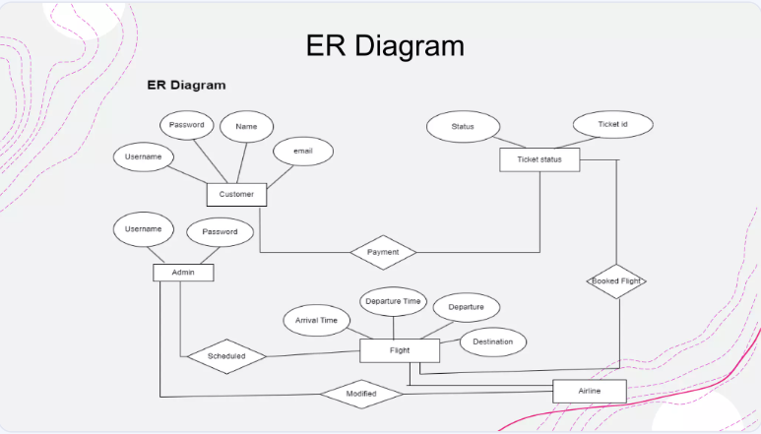

**PROJECT**

**User Interface**: Easy flight search, booking, and management.

**Admin Panel**: Manage flight schedules and bookings.

**Payment Integration**: Secure online payment processing.

**Efficient Database**: Store and manage flight and booking data.

**Scalability & Security**: High performance and data protection.

**Responsive Design**: Works across all devices.

**System Optimization**: Fast, secure, and user-friendly experience.

**DATA FLOW DIAGRAM OF AIRLINE RESERVATION SYSTEM**

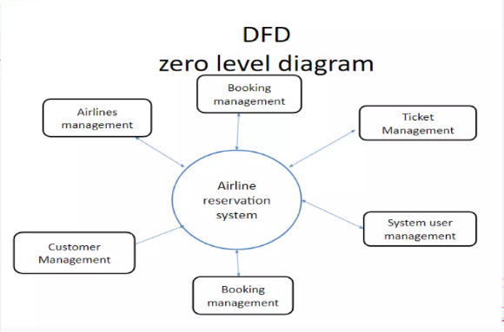

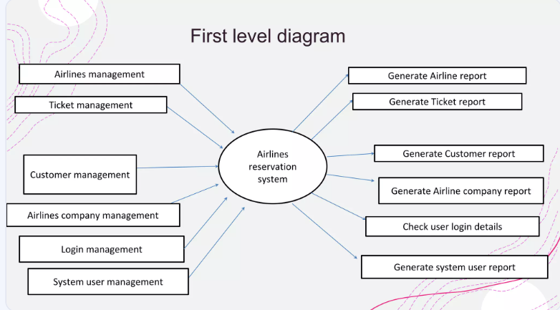

* 1. **ADMIN LOGIN :**

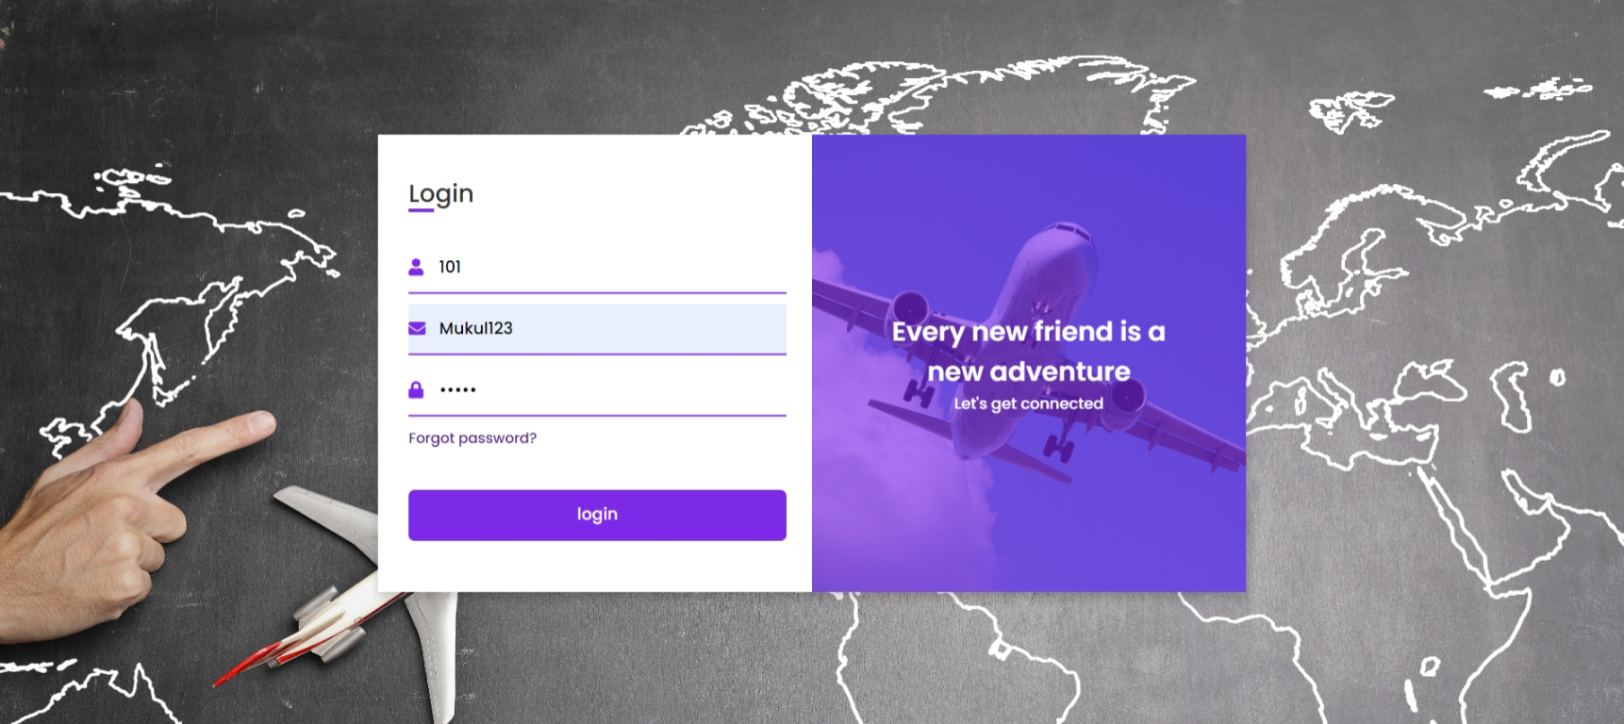

* 1. **AFTER ADMIN LOGIN PAGE :**

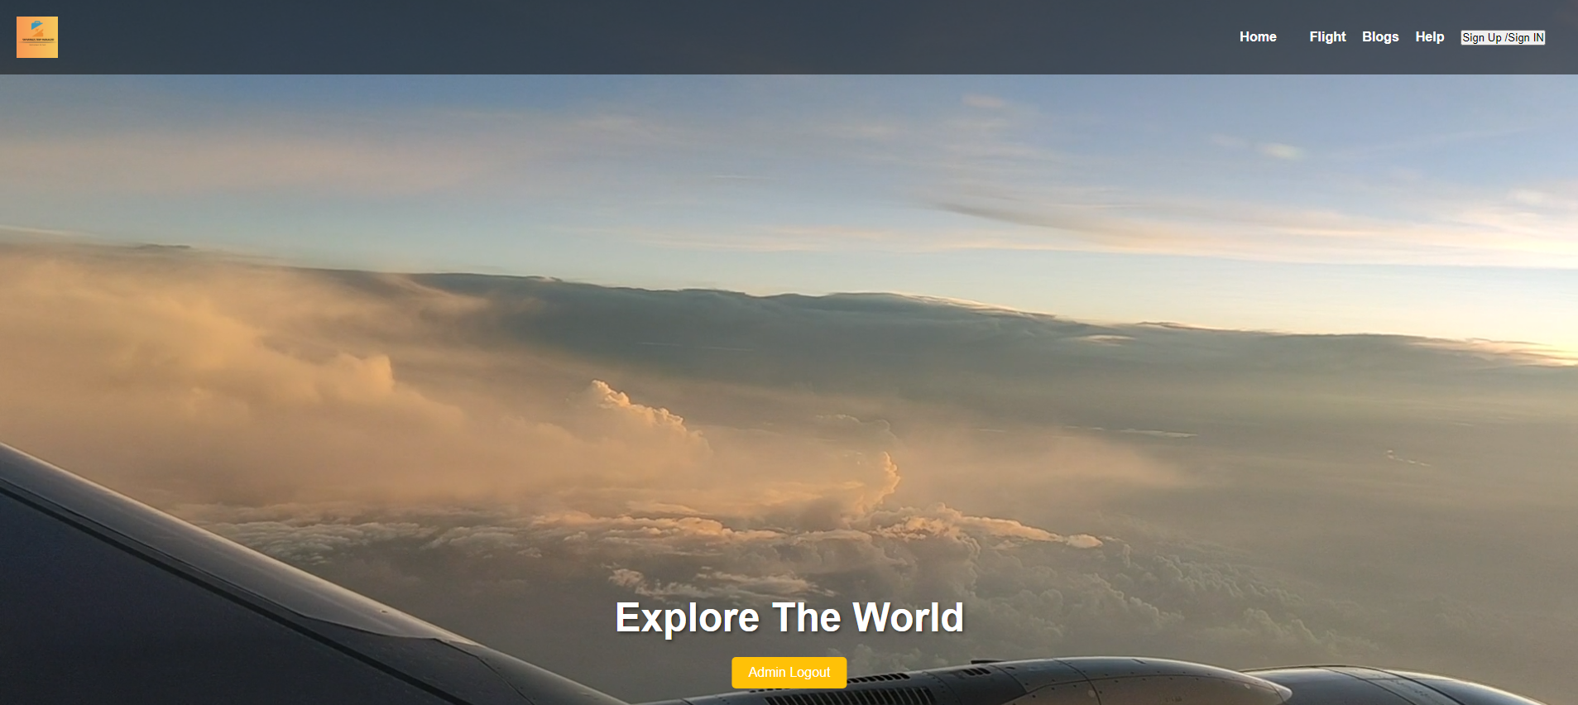

* 1. **CUSTOMER SIGN UP PAGE:**

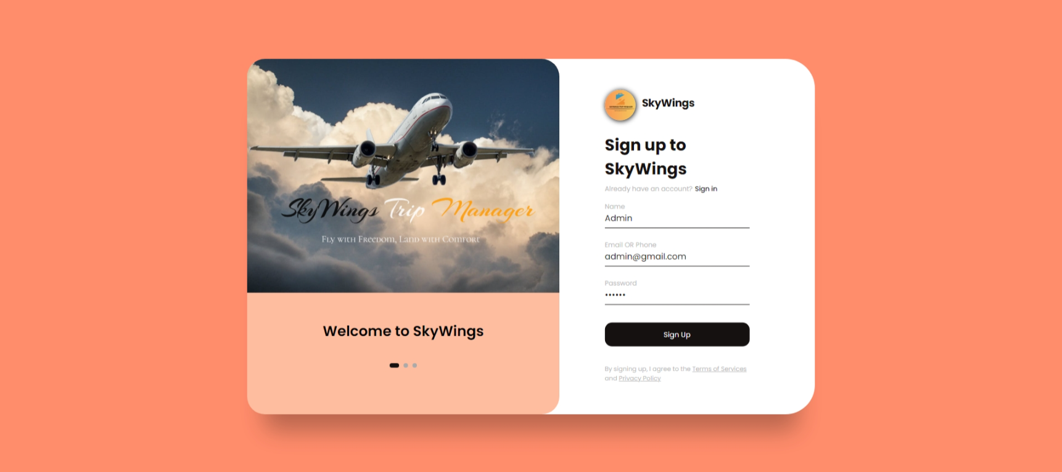

* 1. **CUSTOMER SIGN IN PAGE :**

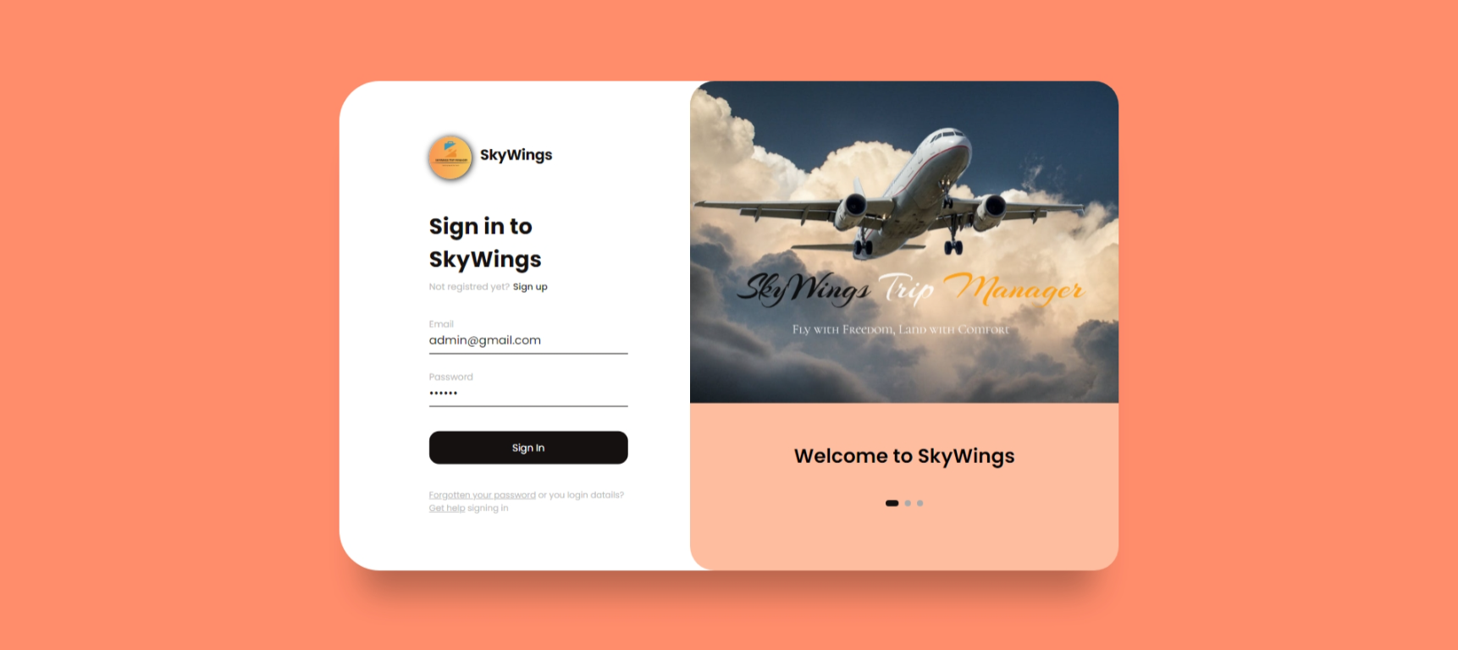

* 1. **HOME (MAIN) PAGE**

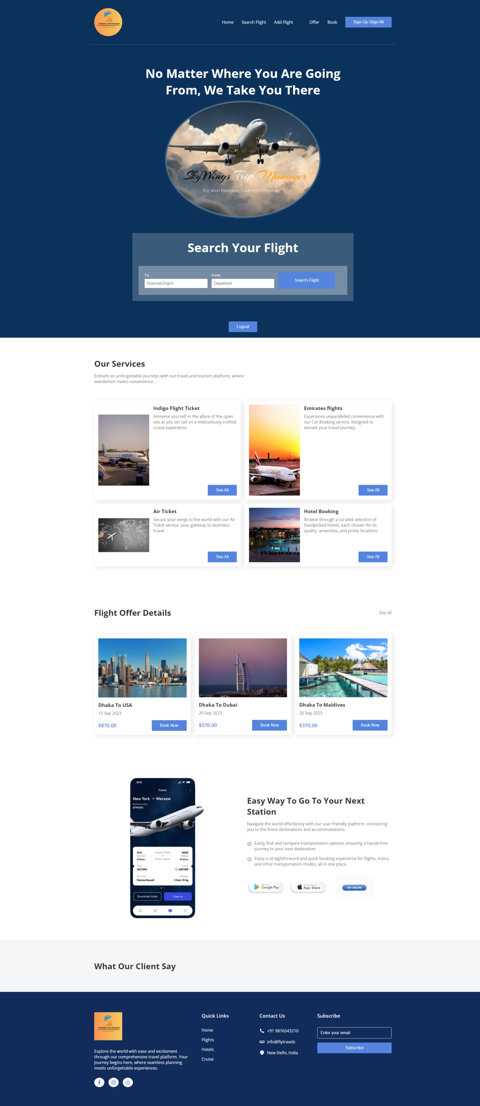

* 1. **REGISTER NEW FLIGHT :**

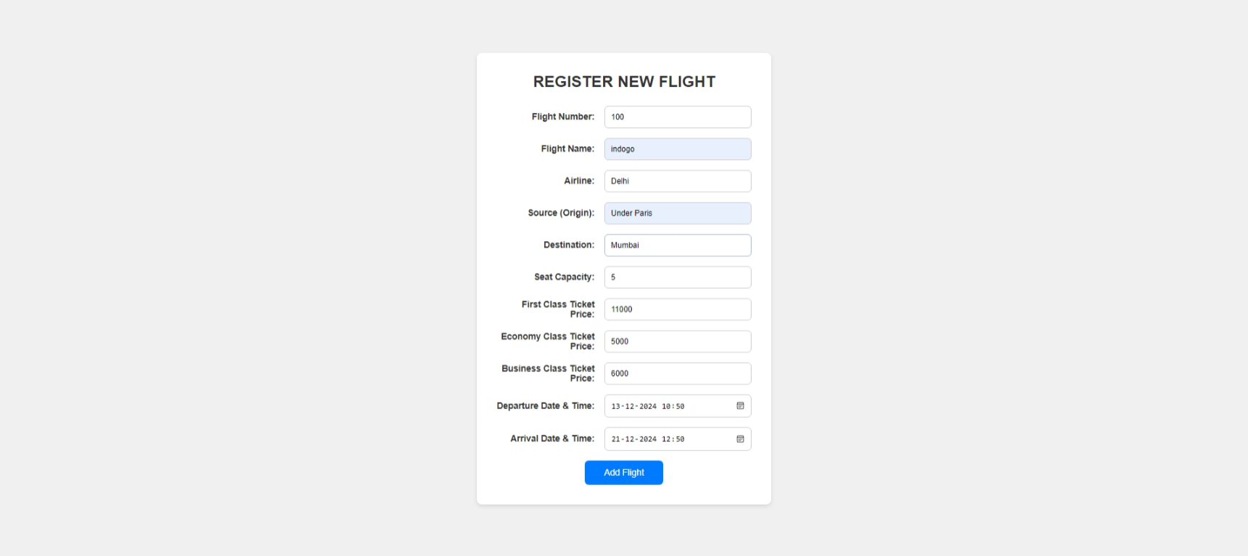

* 1. **SUCCESFULLY ADD NEW FLIGHT :**

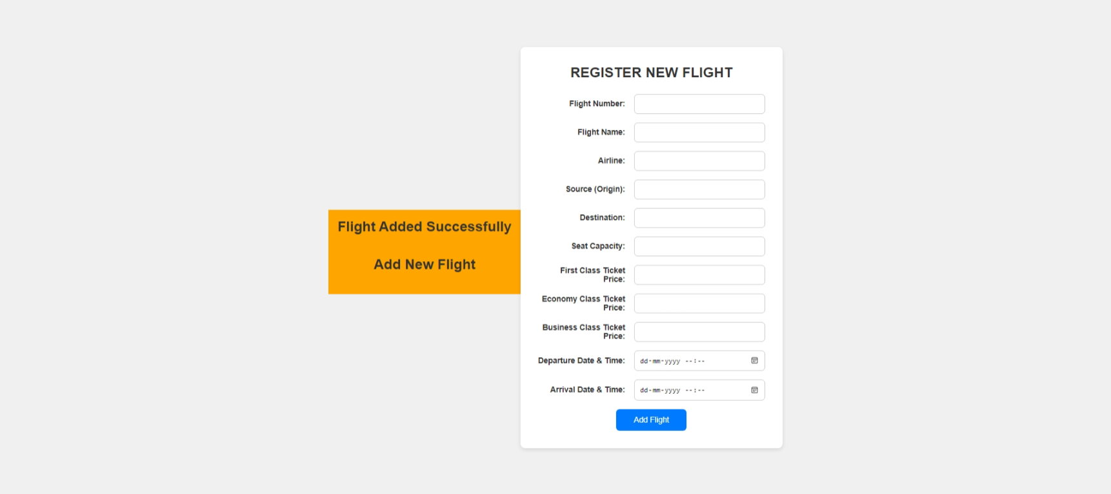

* 1. **AIRLINE BOOKING FORM :**

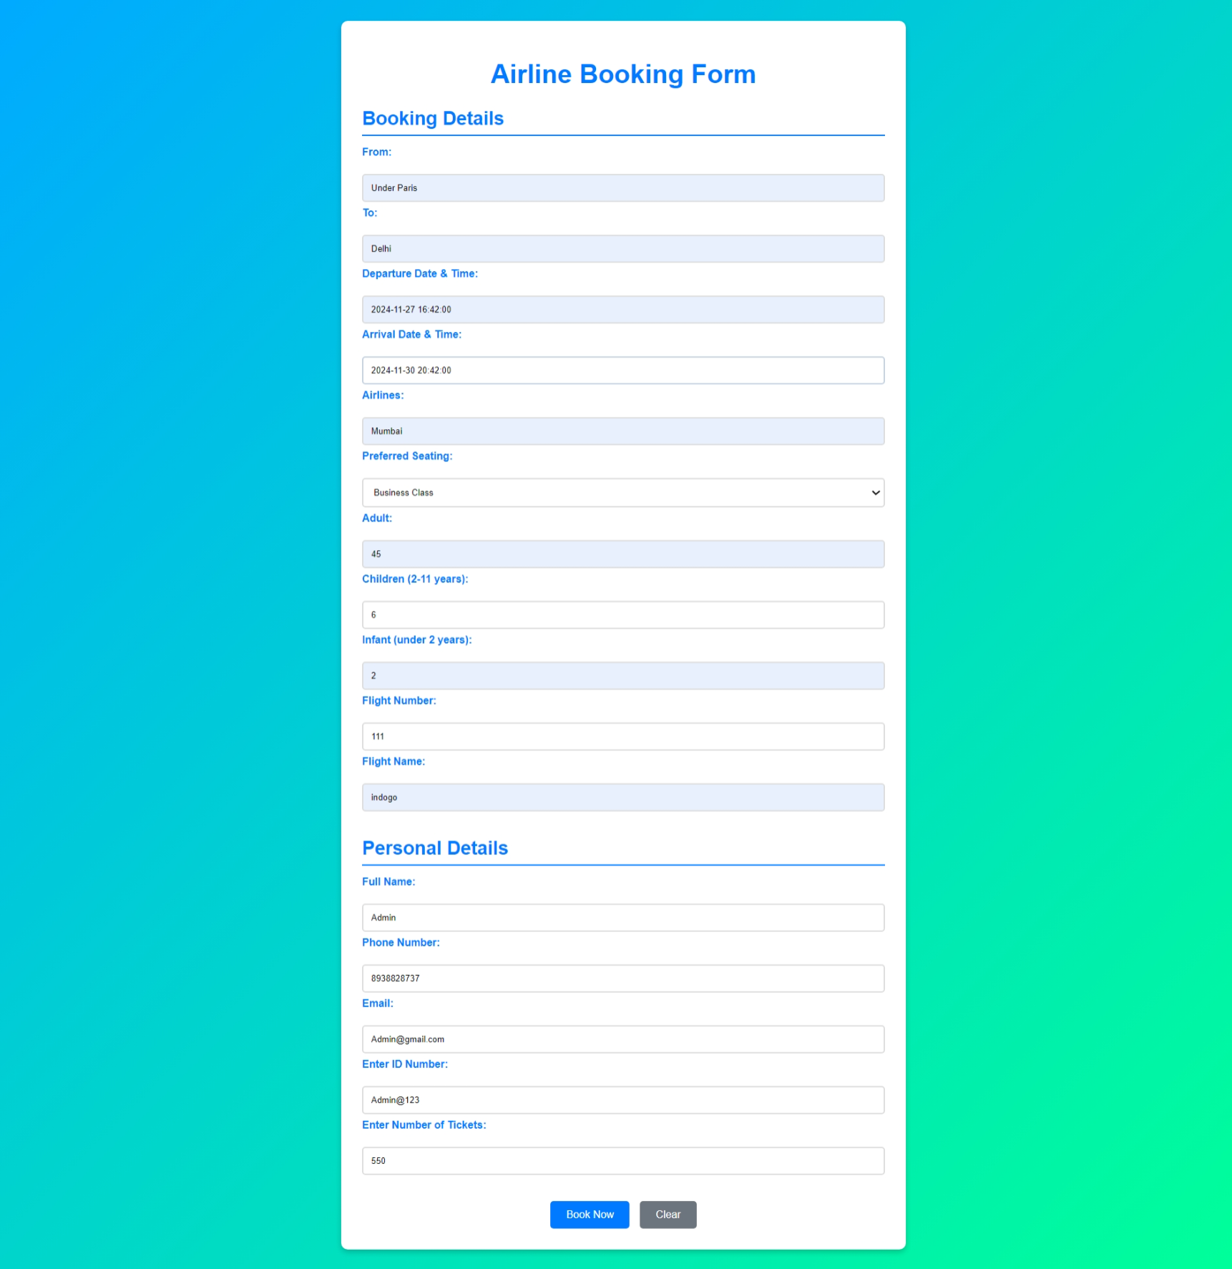

* 1. **LIST OF ALL BOOK FLIGHTS :**

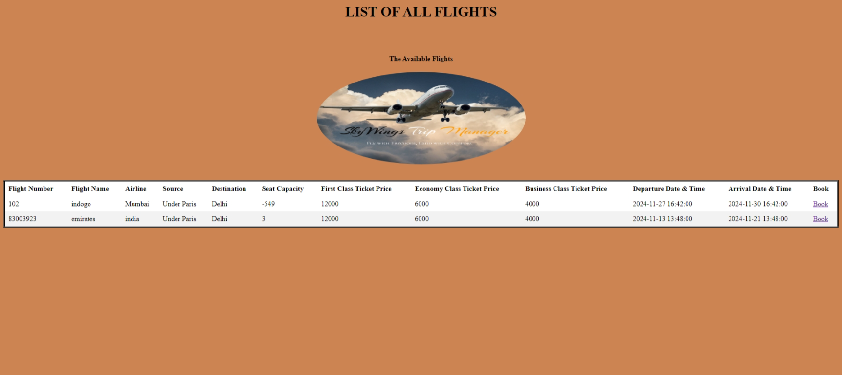

* 1. **CANCEL FLIGHT**



**BACKEND DATA**

**1. FLIGHT DATA**

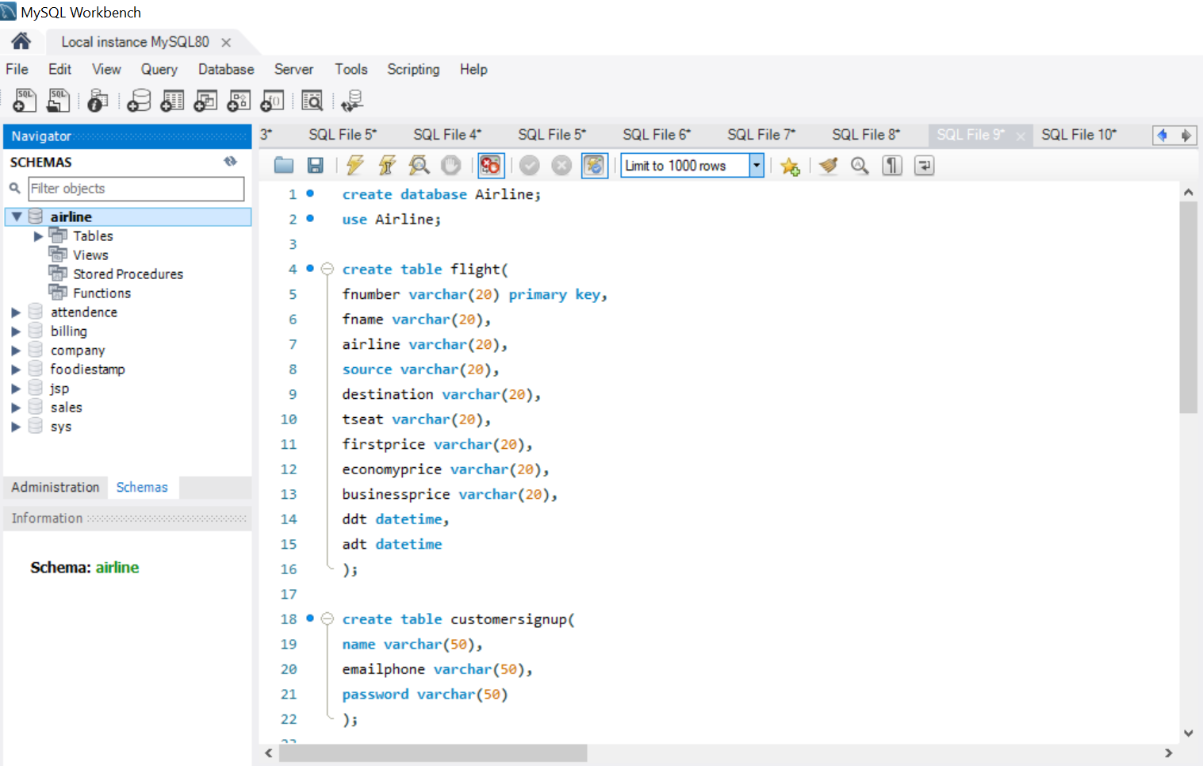

**2. ADMIN LOGIN DATA**

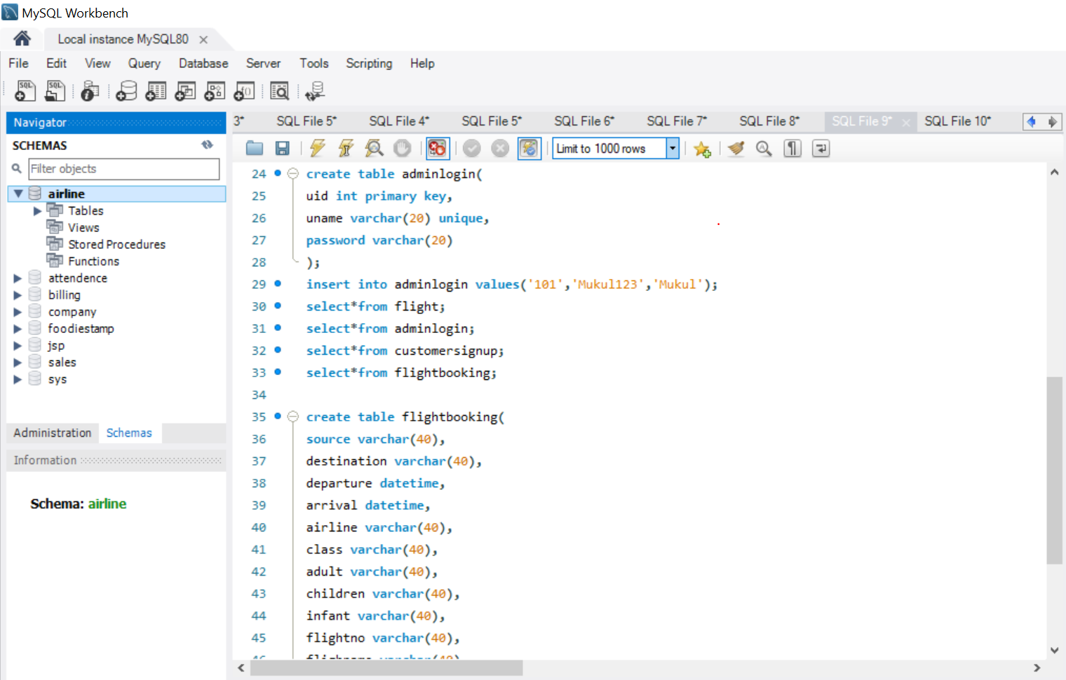

**3. FLIGHT BOKKING DATA**

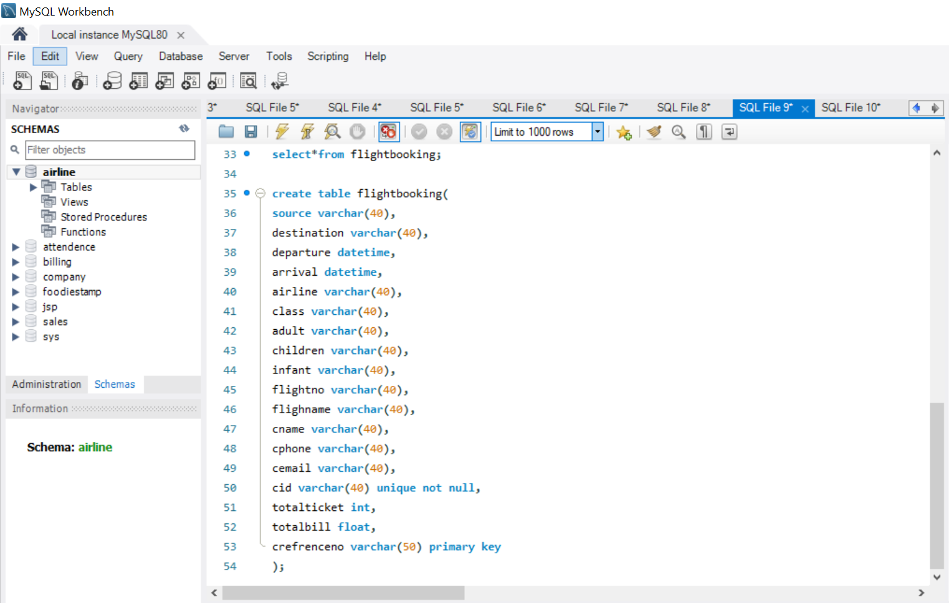

**4 . ADMIN LOGIN TABLE**

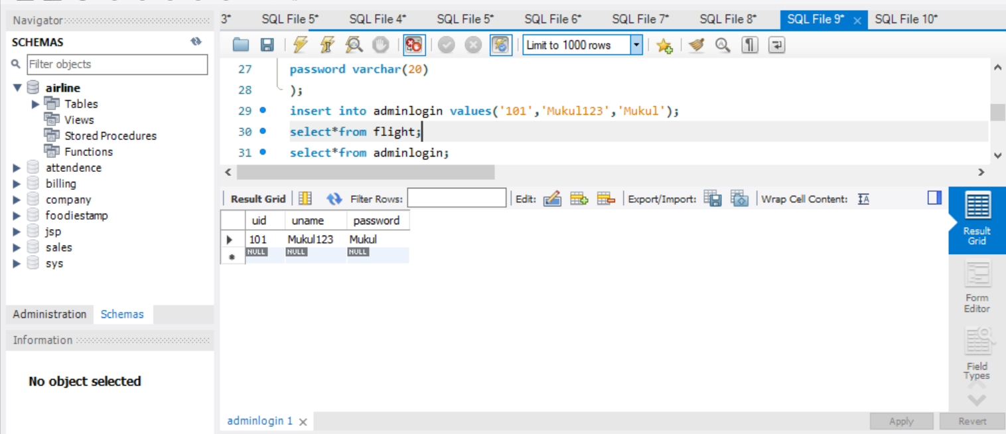

1. **CUSTOMER SIGNUP TABLE**

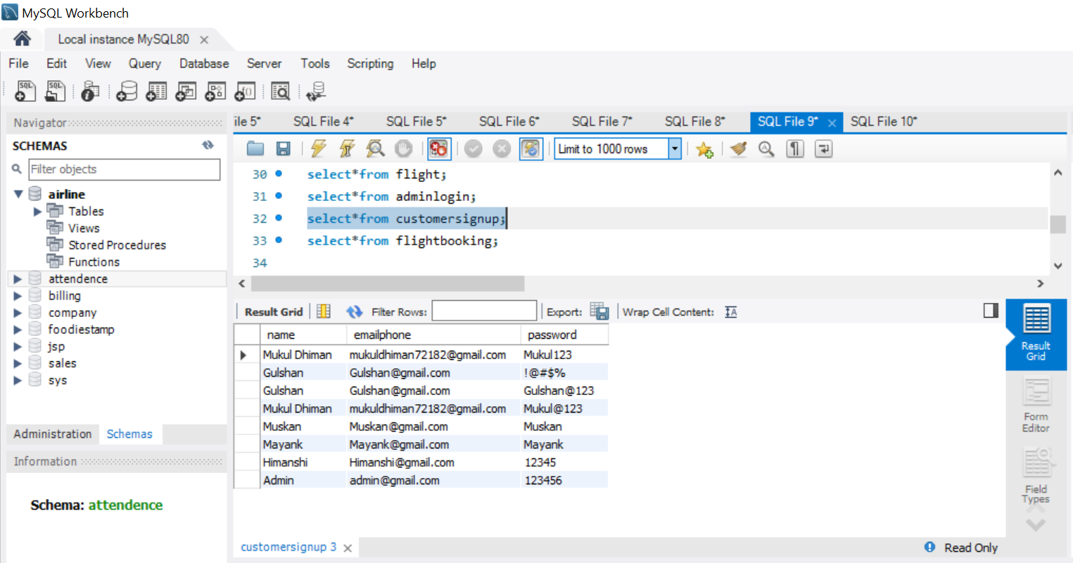

1. **ADD FLIGHT TABLE**

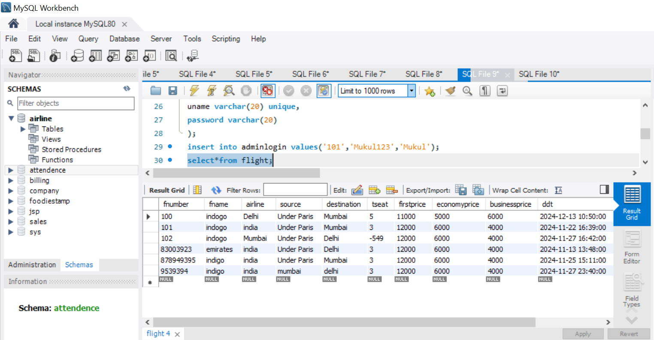

1. **FLIGHT BOOKING TABLE**

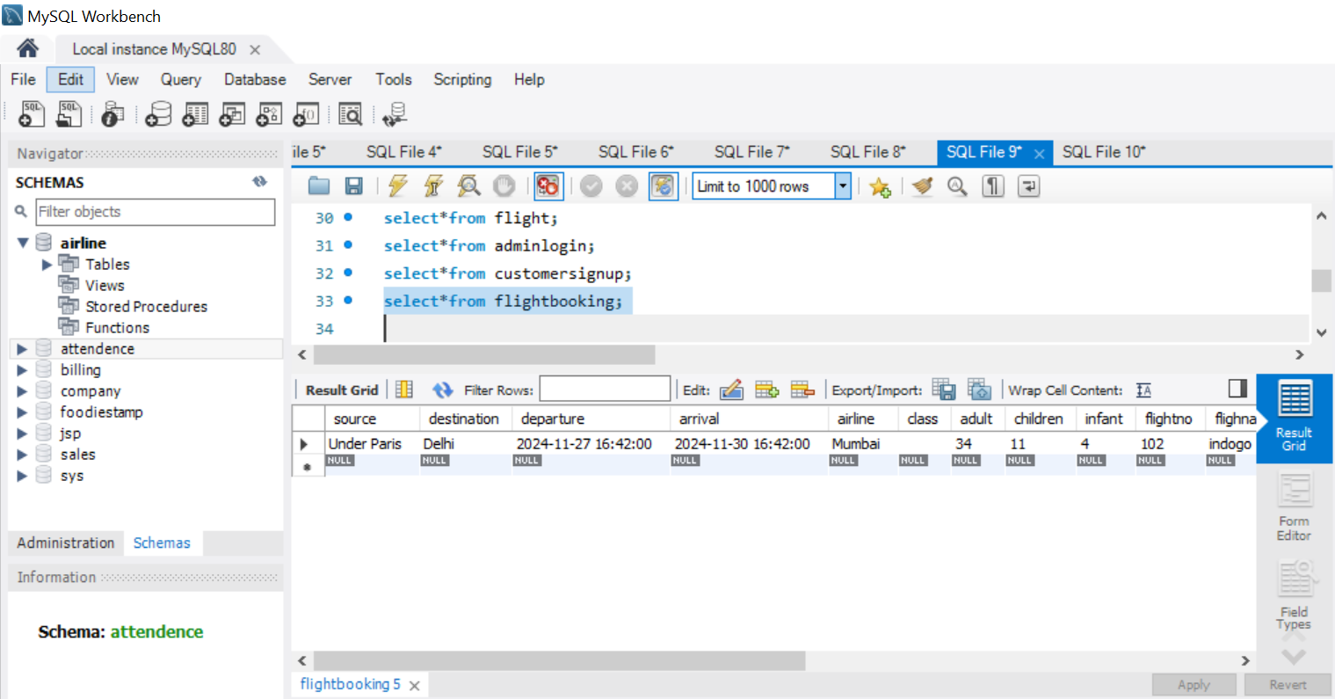

**COLLABORATION DIAGRAM OF AIRLINE RESERVATION SYSTEM**

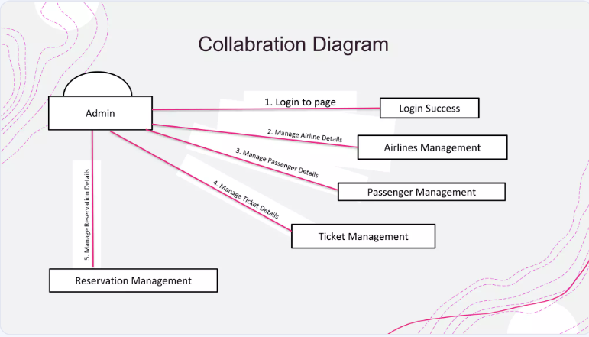

**USE CASE DIAGRAM IN AIRLINE RESERVATION SYSTEM**

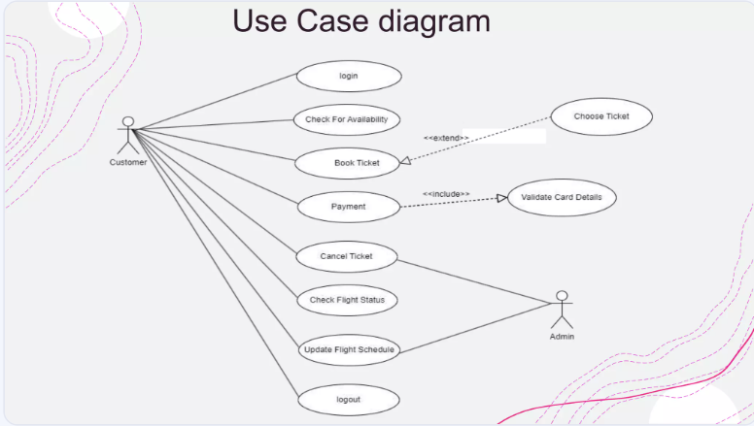

**PROPOSED TIME DURATION**

| **Phase** | **Duration** |
| --- | --- |
| **Requirement Analysis** | **1 Week** |
| **System Design** | **2 Weeks** |
| **Development** | **3 Weeks** |
| **Testing** | **2 Weeks** |
| **Deployment** | **1 Week** |
| **Evaluation and Feedback** | **2 Days** |

**REFERENCE / BIBLIOGRAPHY**

• **Front-End Technologies**

* W3Schools. "HTML and CSS Tutorials". Retrieved from <https://www.w3schools.com>
* Mozilla Developer Network (MDN). "JavaScript Guide". Retrieved from <https://developer.mozilla.org/en-US/docs/Web/JavaScript>

• **Back-End Technology**

* Oracle. "Java Documentation". Retrieved from <https://docs.oracle.com/javase>
* TutorialsPoint. "Java Programming Tutorials". Retrieved from https://www.tutorialspoint.com/java

• **Database**

* MySQL Documentation. Retrieved from <https://dev.mysql.com/doc>

• **Integrated Development Environment (IDE)**

* Apache Tomcat NetBeans IDE. Retrieved from <https://netbeans.apache.org>
* JDK 21

• **Web Development Resources**

* Stack Overflow. "HTML, CSS, JavaScript, and Java-related solutions". Retrieved from <https://stackoverflow.com>
* GeeksforGeeks. "Java and MySQL Integration Tutorials". Retrieved from <https://www.geeksforgeeks.org>